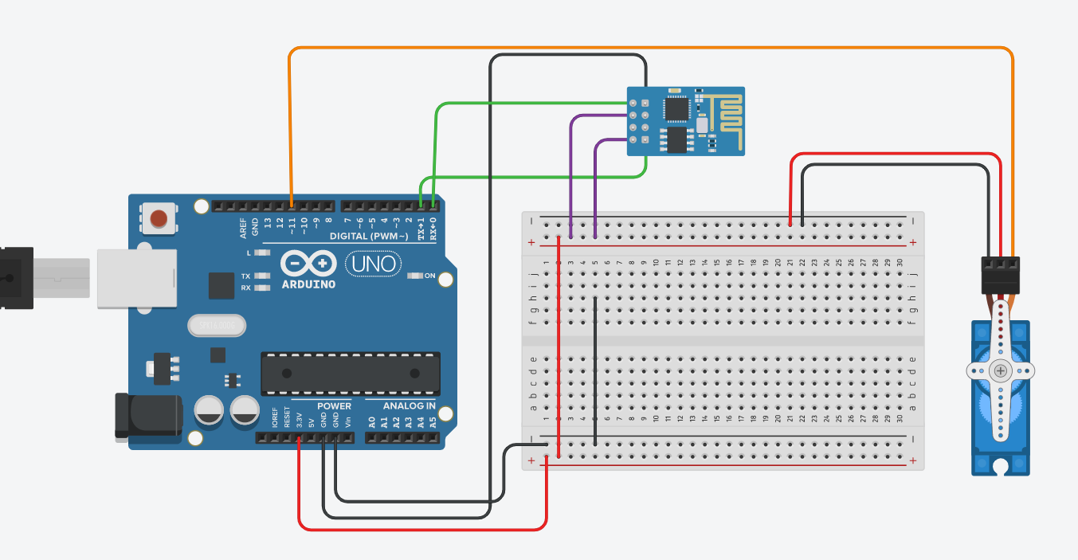

#define BLYNK_PRINT Serial

#include <ESP8266WİFİ.h>

|  |  |
| --- | --- |
|  | #include <BlynkSimpleEsp8266.h> |
|  |  |
|  | #include <Servo.h> |
|  | Servo servo; |
|  |  |
|  | char auth[] = ""; |
|  | char ssid[] = ""; |
|  | char pass[] = ""; |
|  |  |
|  |  |
|  | void setup() { |
|  | Blynk.begin(auth, ssid, pass); |
|  | servo.attach(11); |
|  |
|  | } |
|  |  |
|  | void loop() { |
|  | Blynk.run(); |
|  | } |
|  |  |
|  |  |
|  | BLYNK_WRITE(V0) { |
|  | servo.write(param.asInt()); // 0-179 |
|  | } |